LGE Internal Use Only

LGE VS [OEM Name] [Project Name]

**Software Requirements Specifications**

|  |  |  |  |  |  |  |  |  |  |  |  |  |  |  |  |  |  |  |  |  |  |  |  |  |  |  |  |  |  |  |  |
| --- | --- | --- | --- | --- | --- | --- | --- | --- | --- | --- | --- | --- | --- | --- | --- | --- | --- | --- | --- | --- | --- | --- | --- | --- | --- | --- | --- | --- | --- | --- | --- |
| **About This Template**   * Template Name: LGE_VS_SWRA_T01_SW Requirements Specification(SRS) * Management Department: VS SW Process Team * Revision History  |  |  |  |  |  | | --- | --- | --- | --- | --- | | Version | Date | Comment | Author | Approver | | 3.2 | 2021-08-24 | - Typo, term correction  - Updated security notice of this emplate (Before: LGE Confidential->After: LGE Internal Use Only) Security level related note (the last sentence in red color below) | Soo.Yoon  (VS SW Process Unit) | VS SW Process Unit Leader | | 3.1 | 2019-03-08 | Update due to annual organization restructuring (VC --> VS) | Sangwook Bae | VS SW Process Team Leader | | 3.0 | 2018-07-16 | 1) Refine the requirements attributes and terminology definitions of the General Guidelines.  2) Add content to General Guidelines 7. Administration Tool (related to codeBeamer)  3) Move "About This Document" to Chapter 1. Introduction.  4) The classification of field limited to SRS_ID, SW Requirements, and SysRS_ID in case of word format.  5) Add Use Case example  6) Move existing 7. Standards & Regulations into 6. Design Constraints  7) Add User Interface to External Interface Area | kl.park | VCSmart QE | | 2.1 | 2016-05-30 | Update guidline words partly. | soo.yoon | VC Smart QE FD | | 2.0 | 2016-03-30 | Update overall guidline words. | | 1.7 | 2016-03-11 | Initial Release | |

|  |
| --- |
| **Read me first**   * This template guides how to develop Software Requirements Specifications (SRS) document with the green-colored guideline and example. * This template cannot fit every need or project 100%. Project-optimized tailoring is allowed depending on the scope or characteristics of each project. * Green-colored guidelines should be removed after SRS document is finished. * SRS can be created as a separate document of project unit, subsystem unit, and feature unit. When creating multiple SRSs, enter the target 'Subsystem or Feature Name' in the SRS cover. * The notice “LGE Internal Use Only” is for this template itself. The document which use this template needs to be classified as suitable security level according to its content |

|  |
| --- |
| **General Guidelines!! You should not miss these.**  **1. Traceability of requirements**  It should be possible to figure out which part of the System Requirement Specifications and System Architectural Design the requirements described in the SRS are derived from. For this, create related SysRS_ID and SysAD Element for each requirement. The requirements shall be traceable to subsequent design documents and test specifications.  **2. Attributes of requirements**  When filling out each requirement, you must fill in the attributes below.  When writing as a Word document, only Requirement ID, SW Requirements, and SysRS_ID are included in consideration of the readability of the document, and the rest is managed by Excel or a management system (codeBeamer, Doors, etc.). (Refer to 7. Management Tools)  • Requirement ID: Identifier of the requirement. For traceability, a unique ID must be assigned. The ID creation method is decided in consultation with the project leader or configuration manager.   * + Example: SRS.001   • SW Requirements: ‘3. Write the requirements in compliance with the ‘Ground Rule on Writing Requirements’.  • SysRS_ID: Write the ID of SysRS (System Requirements Specifications) from which the requirements are derived.  • Verification Criteria: Describes the verification method and criteria for verifying the requirements according to the verification method. These criteria can then be used as input for test cases.  SW verification methods include Test (SW Test, SW Integration Test, SW Unit Test), Review (Visual Inspection-actual check, Code Review, Design Review, Document Review), Analysis (FMEA, Static Analysis, SW Profiling, Resource Measurement, etc.), and Demonstration.  Example Verification Criteria:  - Requirement 1: FPGA shall process test pattern command as following sequences. ~~  - Verification Criteria: Verification Method is ‘SW Test’. Check if register value is set for every TestPattern to input. (Refer to ‘Register map’.)  • SysAD Element: Required for traceability between requirements and SysAD (System Architectural Design). Describes the name of the relevant System Element on the System Architecture where the requirements will be implemented.  • Priority: After selecting priorities according to the needs of stakeholders, the priorities of the requirements are written. In this case, a policy for prioritization should be set in advance.  • Status: Draft, Rejected, TBD, Fixed, Deleted (see Section 1.4)  • Type: Heading, Information, IFR, FR, QAR, DCR (refer to Section 1.5)  **3. Ground Rule on Writing Requirements**  • Requirements clearly state the subject, object and method. (Who should do what to whom).  • Items that are not specifically defined at the time of writing the requirements should be written as '(TBD)', and will be revised when they are determined later.  • The requirements are written in an active expression. The requirements are written in the style of “shall”. Avoid negative expressions (Shall Not) that limit the function. When writing a use case, a declarative sentence (without Shall) is used.  • Requirement should be written as an independent unit, but related contents should be structured. (Atomic)  • Do not use “and/or (/, &)” symbols when writing requirements. It leaves room for interpretation in several ways.  • Requirements must be verifiable. Do not use expressions such as “like reasonably”, “appropriately”, “usually”, “quickly”, and “works well” that are difficult to verify.  • Use the abbreviation of the main output of the development stage consistently as follows.  - SysRS: System Requirements Specifications (Requirement ID format: SysRS_ID)  - SysAD: System Architectural Design  - SRS: SW Requirements Specifications (Requirement ID format: SRS_ID)  - SAD: SW Architectural Design  - SDD: SW Detailed Design  • The definitions of System Element, SW Element, SW Component, and SW Unit used in this document are as follows.  - System Element: Components that make up the System (possible to include hierarchical structure)  - SW Element: Components constituting SW (including hierarchical structure), set of SW Modules or SW Components. It is the unit of SDD.  - SW Module: Static component among SW Elements  - SW Component: Dynamic component (Processing Unit) among SW Elements  - SW Unit: The smallest unit of SW that cannot be further divided. function  **4. Document Format**  • Add captions and titles to all figures and tables.  - Automatically insert caption: In Word, select Figure or Table from [Reference] > [Insert Caption] > [Label] and select OK  - Caption position: below the figure, above the table  **5. References**  This template has been revised by referring to the standard specification document related to the SW requirement specification, as well as the SRS template and guide document previously distributed by the company.  • IEEE830_Practice for Software Requirements Specifications  • Automotive_SPICE_PAM_v3.0  • LGE_VS_Template_SW Requirements Specification (SRS)_v1.0  • SRS templates and guidelines previously distributed by the smart division  **6. Others**  • There are no functional safety-related requirements in this template. For projects with ASIL level, some relevant content is added to this document or separate document according to the ASIL level is created.  • Refer to the 'Naming rules for document artifacts' section of the CM guideline managed within the project.  **7. Management Tools**  • For SRS, codeBeamer, Doors, or VIP templates (Word, Excel) can all be used, and it is recommended to use codeBeamer template.  • When using codeBeamer, refer to the following collab.  - Requirements Registration and Management Guide (VS OASIS)  http://collab.lge.com/main/pages/viewpage.action?pageId=993029583 |

About This Document

Document Information

|  |  |
| --- | --- |
| Issuing authority | VS OOO Team |
| Configuration ID | Configuration Item ID in CMBook |
| **Status of document** | In progress / Approved / Released |

Revision History

|  |
| --- |
| Sort the revision history from newest to oldest.  The version mark is ‘target version + Draft indicator’.  e.g, v1.0a: first draft targeting v1.0  e.g, v1.0b: second draft targeting v1.0  e.g, v1.0: v1.0 approved version |

|  |  |  |  |  |
| --- | --- | --- | --- | --- |
| Version | Date | Comment | Author | Approver |
| 1.0 | YYYY-MM-DD | Approved by VR | GD.Hong | OOO |
| 1.0b | 2016-02-20 | Modified by VR  1) 2.1 system context : add interface abc  2) … | GD.Hong |  |
| 1.0a | 2016-01-20 | First draft | GD.Hong |  |

Table of Contents

|  |
| --- |
| Table of contents is automatically created if you use [field update] feature of Microsoft Word. |

1 Introduction 1

1.1 Purpose 1

1.2 Scope 1

1.3 Audience 1

1.4 Conventions 1

1.5 Acronyms / Glossary 1

1.6 Related Documents 2

1.7 Verification Environments 2

2 Overview 3

2.1 SW Overview 3

2.2 SW Main Features 3

3 External Interface Requirements 5

3.1 SW Context 5

3.2 External Interfaces 7

3.2.1 User Interface 7

3.2.2 SW Interface 7

3.2.3 CAN Interface Specifications 8

3.2.4 SPI Interface Specifications 8

4 Functional Requirements 9

4.1 Feature 1 [Example: Application Manager] 9

4.2 Feature 2 [Example: UC1.1 Voice Call Diagnosis] 10

4.3 Feature 3 11

5 Quality Attributes 12

5.1 Quality Attribute 1 [Example] 12

6 Design Constraints 13

6.1 Business Constraints 13

6.2 Technical Constraints 13

6.3 Standards & Regulations 13

Figures

|  |
| --- |
| Table of contents is automatically created if you use [field update] feature of Microsoft Word. |

Figure 3.1 Software Context Diagram (Example) 6

Tables

|  |
| --- |
| Table of contents is automatically created if you use [field update] feature of Microsoft Word. |

Table 2.1 Software Main Features 3

Table 2.2 UC11 Hierarchy Use Case List 4

Table 3.1 External Interface list 7

Table 3.2 SW Interface 7

Table 3.4 CAN message list 8

Table 3.5 SPI Interface list 8

# Introduction

## Purpose

|  |
| --- |
| Describe the purpose of this document. |

This document is a Software Requirement Specification (SRS) of xxxx. This SRS is a result which describes software requirements analyzed by LGE. Each software requirement in this document is traced from the System Requirements Specifications (SysRS).

## Scope

|  |
| --- |
| Describe the scope of this document. |

* Scope covered by this document:
* Scope of this document (OEM/model/country):
* Scope of development / undeveloped scope of this project:

## Audience

|  |
| --- |
| Describe the audience (main stakeholders) of this document. |

The target audience of this document is:

OEM (Customer), Requirement engineer, System/Software architect, Component developer, Project Manager, Quality Manager, Test Engineer

## Conventions

|  |
| --- |
| If there is a notation used in this document, explain it. |

Example 1: unit of measure

**Units**

The unit of speed keeps consistency for each destination.

Japan: km/h

U.S.: mile/h

Example 2: This document follows UML notation 2.0

Example 3: Status

: Draft, Rejected, TBD(not fixed), Fixed, Deleted(Fixed and deleted)

## Acronyms / Glossary

|  |
| --- |
| Describes abbreviations used in this document and their interpretations. In the table, the abbreviations/terms are indicated in alphabetical order. In addition to explaining abbreviations, it is written when explanations of terms are required. |

|  |  |
| --- | --- |
| Acronym | Description |
| CAN | Controller Area Network |
| DCR | Design Constraints |
| DD | Download Descriptor |
| ERR | External Remote Reflash |
| FR | Functional Requirements |
| IFR | Interface Requirements |
| IRR | Internal Remote Reflash |
| LIN | Local Interconnect Network |
| QAR | Quality Attribute Requirements |
| SAD | Software Architectural Design |
| SDD | Software Detailed Design |
| SPI | Serial Peripheral Interfaces |
| SRS | Software Requirements Specifications |
| STID | Station ID |
| SysAD | System Architectural Design |
| SysRS | System Requirements Specifications |
| VM | Verification Method |
| VC | Verification Criteria |

|  |  |
| --- | --- |
| Glossary | Description |
| OOOO | OOOOOOOOOOOOOOOOOOOOOOOOOOOOOOOOOOOOOO |
|  |  |
|  |  |

## Related Documents

|  |
| --- |
| Documents related to this document and a list of referenced documents are described.  Includes all parent documents. |

Documents related to this document include:

[1] LGE, Customer Requirements Specifications, pjt_CRS, v1.0[, Date]

[2] LGE, System Requirements Specifications, pjt_SyRS, v1.0[, Date]

[3] LGE, System Architecture Design, pjt_SyAD, v1.0[, Date]

[4] Author, Document title, Document version [, Date] , [Page]

Documents referenced from this document include:

[11] LGE, SRS template, pjt_SRS_feature (LGE VS SRS tpl v3.0), 2017.6.10

## Verification Environments

|  |
| --- |
| When creating Verification Criteria for each requirement, if there is a common reference such as test environment, it is defined here and used in the document. |

[Ve1] Face: FDDC-238

[Ve2] Eyes: FDDC-3054

[Ve3] Canoe

[Ve4] Measurement system

# Overview

## SW Overview

|  |
| --- |
| * Briefly describe what the software is. * Software name, scope, purpose * Background information which aids understanding of the software * Software structure and its characteristics |

*The IHU Main element is responsible for operating the Infotainment Head Unit (IHU).*

*At startup, it determines the startup sequence for applications depending on various contexts including Last User Context (LUC), car configurations.*

*Once the IHU is started, the IHU Main manages the lifecycle of applications such as resuming application, pausing application and restarting application abnormally terminated for reliabilities.*

*For those purposes, the IHU Main element interacts with various external components including WebAppFramework to support web app runtime. The IHU Main element consists of three major parts; App Manager, App Launcher and AppCommonAPI.*

## SW Main Features

|  |
| --- |
| * Example 1: Describes the main function of SW to be developed in the form of text or tables. If the function consists of several levels, tabulate. * Example 2: Write a Level 1 Use case diagram and a table describing it. * When a document is written by each feature saperately, the full description is vulnerable to change and therefore only describes the scope of the feature. * If this software is derived from the existing software, describe new or modified functions, interfaces, capabilities, and other changes compared to the existing software. |

**Example 1**

Table 2.1 Software Main Features

|  |  |  |  |
| --- | --- | --- | --- |
| **Level 1** | **Level 2** | **Level 3** | **Descriptions** |
| *Multimedia* | *Audio Player* | *Disc Audio Player* | *Plays music that is stored in disc. (CD, MP3, DVD)* |
| *USB Audio Player* | *Plays music that is stored in USB* |
| *Telematics* | *Telephony* | *Voice Call Answer* | *Answers the incoming voice call.* |
| *Voice Call Request* | *Requests voice call connection to the given number.* |
| *Call Center Request* | *Requests connection to the given call center.* |
| *Remote svc* | *Remote Door Lock* | *Remote door lock* |
| *Remote Engine Control* | *Remote engine control* |
| … |  |  |  |

***Example 2***

*The following is an example of a Use case diagram for the UC11 Personal Call feature.*

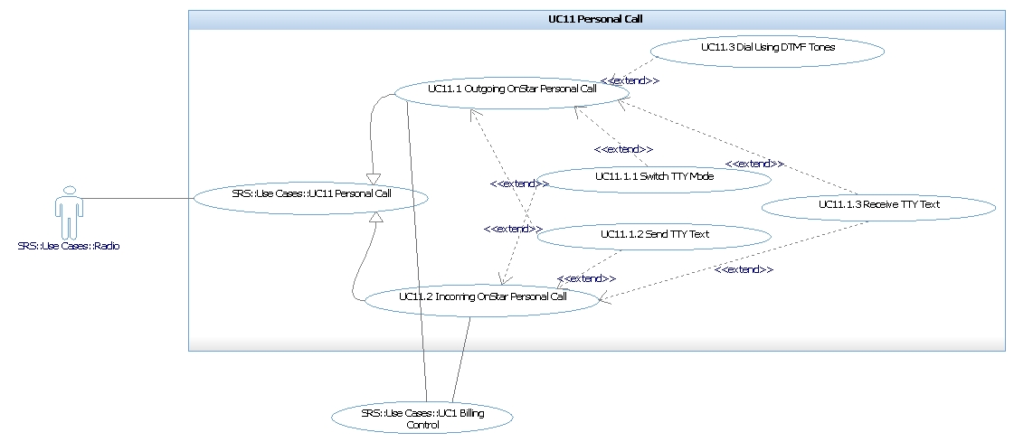

**Figure 2.1 UC11 Personal Call Use case diagram**

Table 2.2 UC11 Hierarchy Use Case List

|  |  |  |
| --- | --- | --- |
| **L1 UC_ID** | **L2 UC_ID** | **Descriptions** |
| *UC11 Personal Call* | *UC11.1 Outgoing Persona call* | *…* |
| *UC11.1.1 Switch TTY Mode* |  |
| *UC11.1.2 Send TTY Text* |  |
| *…* |  |
|  |  |

# External Interface Requirements

|  |
| --- |
| * Identify the external interface (Type) of the SW development Scope through the Context Diagram (Section 3.1), and describe in detail in Section 3.2 for each Interface Type. * Each interface in section 3.2 should be identified at the individual message level and describes ID, purpose, Source, Destination, Communication Type, Data Item (including possible Type / Range). If there are constraints like timing, protocol, describe them together.. * Each interface must be referenced by SRS_ID (or UC_ID) to be used as input / output of Functional Requirement. |

## SW Context

|  |
| --- |
| * Define context diagram, which shows how the software is required to interact with external entities. (If necessary, refer to System Architecture Design.) * The context diagram represents external interfaces such as HW interface, SW interface, and Communication interface. * HW interface means interaction between SW and external HW. It is specified in the HIS (HW/SW interface specifications) document instead of SRS. * In Context Diagram, the lines marked with external interface should be classified by type, and the legend must be clearly defined. * Inside the Context Diagram, the SW that is to be developed can be treated as a black box or an internal functional configuration (logical architecture rather than physical configuration). * Under the Context Diagram image, describe what function the external SW is. * In the case of pure SW development, if the use case diagram is used in Section 2, this clause can be omitted because it includes Context. However, in case of embedded SW, if HW-SW interface is identified in SysAD, it should be included in context Diagram. |

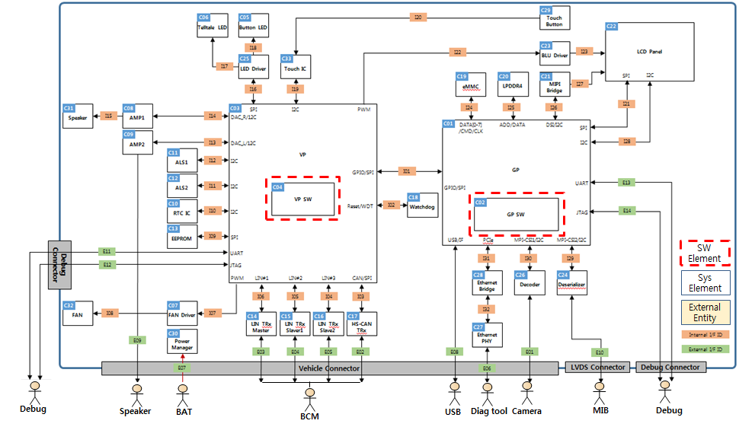

Figure 3.1 Software Context Diagram (Example)

The SW context diagram shows the interface between the Software and the following external components.

* **User Input**: This component shall communicate with Home application to launch other application.
* **…**.

## External Interfaces

Define a message that used in the external interface identified at the SW Context.

It can be divided into sub-sections by type (UI, API, CAN, SPI, LIN, etc.) or all interfaces can be written in one table. If you create all the interface messages in one table, you can omit the sub-clause. The UC_ID column in the table below can be used as a function ID if the use case is not used. SRS_ID can be Use case ID_seq. #, when use case is used.

Table 3.1 External Interface list

|  |  |  |  |  |  |  |  |  |
| --- | --- | --- | --- | --- | --- | --- | --- | --- |
| SRS_ID | IF_ID | Message | Type | Source | Direction | Destination | Description | UC_ID |
| *EX1_1* | *I01* | *SetupRQ* | *CAN* | *IHU* | *->* | *MCU_SW* | *…* | *UC3.1* |
| *EX1_2* | *I01* | *SetupRP* | *CAN* | *IHU* | *<->* | *MCU_SW* |  | *UC3.1* |
| *EX1_3* | *I02* | *IncVoice* | *API* |  | *->* | *MCU_SW* |  | *UC3.2* |
|  | *I04* | *ReleaseRQ* | *SPI* | *MPSoC_SW* | *<->* | *MCU_SW* |  | *UC3.3* |
|  | *I05* | *ConnectRQ* | *LIN* | *IHU* | *->* | *MCU_SW* |  | *UC3.4* |

Ref. [x] for message detail

### User Interface

Describe the user interface identified in the SW Context as figures and tables.

(See Table 3.1 for form)

### SW Interface

|  |
| --- |
| Describe the SW interface with the external entities identified in the SW Context.  Generally, they are interfaces provided in API form at the code level. |

Table 3.2 SW Interface

|  |  |  |  |  |
| --- | --- | --- | --- | --- |
| No | Source | Interface Name | Description | UC_ID |
| 1 |  | Native App Interface | Exchanges application related information that needs to be shared with App Manager |  |
| 2 |  | Wayland Interface | Requests Wayland Server to show a specific surface. |  |
| 3 |  | AM Interface | Provides audio related information such as audio channel allocation, audio mode change event. |  |
| 4 |  | WAM Interface | Controls and monitors web app via the WAM (Web Application Manager). |  |

### CAN Interface Specifications

For details, refer to the ‘xxx.xlsx’ document.

Table 3.4 CAN message list

|  |  |  |  |  |  |  |  |  |  |
| --- | --- | --- | --- | --- | --- | --- | --- | --- | --- |
| No | Signal Name | Source | RX  /TX | Signal Descriptions | Signal Byte No. | Signal Bit No. | Signal Length | Signal Default | UC_ID |
| 1 | ISw_Stat | IHU | RX | Ignition switch state | 2 | 4 | 3 | 07H |  |
| 2 | DidA_ExtTest_Pres |  | RX | DidA external tester present | 5 | 0 | 1 | 00H |  |
| 3 | TGW_Rout_Stat |  | RX | TGW routing status | 1 | 0 | 2 | 00H |  |
| 4 | DISP_C_Heat_Mgtm |  | TX | Status Heat Management | 1 | 0 | 2 | 00H |  |
| 5 | SPV_Rem_Vol_Psd1 |  | TX | Splitview Remote Volume + | 1 | 2 | 1 | 00H |  |
| 6 | SPV_Rem_Vol_Psd2 |  | TX | Splitview Remote Volume - | 1 | 3 | 1 | 00H |  |

### SPI Interface Specifications

For details, refer to the ‘xxx.xlsx’ document.

Table 3.5 SPI Interface list

|  |  |  |  |  |  |  |
| --- | --- | --- | --- | --- | --- | --- |
| No | Register Name | Descriptions | Offset | Initial Value | R/W | UC_ID |
| 1 | fpgaID0 | FPGA image ID0 | 0x0000 | TBD | RO |  |
| 2 | fpgaID1 | FPGA image ID1 | 0x0002 | TBD | RO |  |
| 3 | lockStatus | Signal Lock Status | 0x0004 | 0xXXXX | RO |  |
| 4 | blockEnable | HUS/ICS Block Enable | 0x0006 | 0x0000 | RW |  |
| 6 | interruptEnable | Interrupt Enable | 0x000a | 0x0000 | RW |  |

# Functional Requirements

|  |
| --- |
| * Describe functional requirements of the software features provided in the ‘1.2 SW Main Features’ section of this document. * Describe the functional requirements of the software that is allocated as ‘SW’ in the System Requirements Specifications (SyRS). * Functional requirements can be largely divided into requirements for interaction with external actors and internal function actions. * Function which has internal behaviors that do not provide UI.   : Specify the logical internal behavior of the function.  *i.e., “Terminal shall use SMS bearer to send SMS to e-mail address.”*   * Function which needs interaction with external actor   : Specify the functional requirements that enable user to recognize the function behavior flows. Use-case diagram makes it easier for interactions to be clearly identified.  *i.e., “Terminal shall allow user to create a new e-mail account.”*   * Read ‘2. Requirements attributes’ of ‘General Guidelines’ before writing this section. * In the case of a feature composed of several functions, related requirements are collected and described. * Classification of requirements: The requirements have the following classification field for each requirement in the requirements management system. Word documents only have SRS_ID, SW Requirements, and SysRS_ID. |

Table 4.1 Example of classification fields in a requirements management system

|  |  |  |  |  |  |  |  |  |
| --- | --- | --- | --- | --- | --- | --- | --- | --- |
| **SRS_ID** | **SW Requirements** | **SysRS_ID** | **Status** | **Type** | **Sys Element** | **Priority** | **VM** | **VC** |
|  |  |  |  |  |  |  |  | **‘****Verification Criteria**’ can be refered. |

## Feature 1 [Example: Application Manager]

|  |  |  |
| --- | --- | --- |
| **SRS_ID** | **SW Requirements** | **SysRS_ID** |
| SRS.001 | Application Manager shall provide an interface to retrieve information of the installed applications for the users.  - application name  - application description  - AV configuration  - mapping HW keys  - icon path  - binary path | SysRS.001 |
| SRS.002 | Application shall have manifest file that specifies what it provides and what it requires. The manifest file shall include following information:  - app description, vendor and title  - icon information  - app ID  - executable location  - version  - HW key (this key will trigger the application to go to the foreground)  - AV information | SysRS.002 |

|  |
| --- |
| * The following is an example of using a use case analysis method, which is suitable for the requirement of interacting with an external actor. * Use case description for all use cases should be identified in Chapter 2 Use case diagram as below. * SRS_ID should be given for basic flow, alternative, exception, special requirement. Among them, the description not the scope of development does not attach SRS_ID. * When using a use case, it is recommended to use Use case ID as SRS_ID. |

## Feature 2 [Example: UC1.1 Voice Call Diagnosis]

|  |  |  |
| --- | --- | --- |
| **SRS_ID** | **SW Requirements** | **SysRS_ID** |
|  | *Brief Description: <* *Describe including the goal of the UC. >* |  |
|  | *Actor / Event :* |  |
|  | *Precondition: Application is in Installed state* |  |
| *UC1.1_1*  *UC1.1_2*  *UC1.1_3* | *Basic flow: <Basically goal is the basic flow.>*  *1. The engineer connects to the equipment and obtains certification..*  *2. The engineer*  *a) Enter the default number for automatic voice call.*  *b) Enter the SMS default number.*  *3. The system saves the number and returns the result* | *SysRS.011* |
|  | *Post Condition :* |  |
| *UC1.1_4*  *UC1.1_5*  *UC1.1_6*  *UC1.1_7* | *Alternative Flow: < Another flow to achieve the goal. Branch point from the basic flow should be displayed.>*  *1a. In case that authentication fails*  *1a.1 Print a message that authentication failed.*  *1a.2 It tries authentication repeatedly x times, and if all fails, it will block the system connection for y minutes.*  *3a. If the system fails to store the number, the system displays 'No. saving failed'.* | *SysRS.012* |
| *UC1.1_8* | *3a. If the system fails to store the number, the system displays 'No. saving failed'.* | *SysRS.013* |
| *UC1.1_9* | *Special requirements:* |  |
|  | *Informations:* |  |

## Feature 3

….

# Quality Attributes

|  |
| --- |
| * Describe the quality attributes (non-functional requirements). * You can see the types of software quality attributes as below. (based on ISO 9126)      * Read ‘2. Requirements attributes’ of ‘General Guidelines’ before writing this section. * Please keep in mind below when you describe SW quality attributes. * Quality attributes are quantitative requirements and are verifiable individually. * Specify the unit, goal, valid value range (maximum, minimum) of quality attribute if needed. * Use case ID_seq. # can be used as SRS_ID when use case is used.   Ex) In the case of the third QAR related to UC 1, it is indicated as QA1_3. |

## Quality Attribute 1 [Example]

|  |  |  |
| --- | --- | --- |
| **SRS_ID** | **SW Requirements** | **SysRS_ID** |
| SRS.301 | Reliability: The count of restarting application shall be limited within 3 times for system performance when application is terminated abnormally. | SysRS.301 |
| SRS.302 | Performance: Maximum start-up time for main display HMI shall be 12 seconds.  Agreed deviation in document "LGE CMA IHU Deviation list" is:  a. Non-AV app : 9 seconds  b. AV app : 14 seconds | SysRS.302 |
| … |  |  |

# Design Constraints

|  |
| --- |
| * Constraints are predetermined decisions that developers must meet when designing or implementing the proposed software. * Describe a requirement that limits the options open to a designer and developer of a solution by imposing immovable limits * Examples of constraints include: * *technology, patent, design tool, development tool, programming language, and database to be certainly used or to be avoided* * *development rules (e.g., coding rule, build version) to be adhered to* * *hardware limitation* * *operational environment limitation* * Use case ID_seq. # can be used as SRS_ID when use case is used.   Ex) In the case of the 3rd Design Constraints related to UC 1, it is displayed as DC1_3 |

## Business Constraints

## Technical Constraints

|  |  |  |
| --- | --- | --- |
| **SRS_ID** | **SW Requirements** | **SysRS_ID** |
| SRS.401 | The core eCall functionality shall be implemented as natively as possible and in a way that problem in the software architecture (e.g. Java VMs, abstraction layers) do not have influences in the initiation of the eCall. | SysRS.401 |
| SRS.402 | The eCall core functionality (MOD_ECLL_5759) shall include the following components:  - Receiving trigger for automatic and manual activation  - MSD generation / Transmission  - voice call via microphone and emergency loudspeaker (including discrete mute) | SysRS.402 |
|  | *Examples of memory constraints: The memory available in the proposed system is 160 KB in the Flash ROM area, 4 KB internal RAM and 64 KB external RAM.* |  |

## Standards & Regulations

|  |  |  |
| --- | --- | --- |
| **SRS_ID** | **Contents** | **SysRS_ID** |
|  | ISO 22901-1 Road Vehicles - Open Diagnostic Data Exchange(ODX) - Part 1: Data Model Specification |  |
|  | ISO 22901-2 Road Vehicles - Modular vehicle communication interface (MVCI) - Part 2: Diagnostic protocol data unit |  |